Create a React App named “bloggerapp” in with 3 components.

1. Book Details
2. Blog Details
3. Course Details

Implement this with as many ways possible of Conditional Rendering.

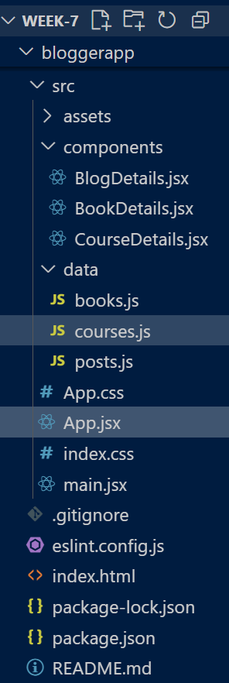

**App.jsx:**

import { useState } from 'react'

import BookDetails from "./components/BookDetails";

import BlogDetails from "./components/BlogDetails";

import CourseDetails from "./components/CourseDetails";

import { books }   from "./data/books";

import { posts }   from "./data/posts";

import { courses } from "./data/courses";

export default function App() {

  const [showBooks,   setShowBooks]   = useState(true);

  const [showBlogs,   setShowBlogs]   = useState(false);

  const [showCourses, setShowCourses] = useState(true);

  return (

    <div style={{ display: "flex", gap: 40, padding: 20 }}>

      {/* 1) Element Variables */}

      <div>

        <h2>Book Details</h2>

        {(() => {           // IIFE returning either component or fallback

          if (showBooks) return <BookDetails books={books} />;

          return <p>No books to show.</p>;

        })()}

      </div>

      {/* 2) Inline Ternary */}

      <div>

        <h2>Blog Details</h2>

        {showBlogs

          ? <BlogDetails posts={posts} />

          : <p style={{ color: "#888" }}>Please enable Blogs</p>

        }

      </div>

      {/* 3) Logical && */}

      <div>

        <h2>Course Details</h2>

        { showCourses && <CourseDetails courses={courses} /> }

        { !showCourses && <p>Courses hidden</p> }

      </div>

    </div>

  );

}

